**Project Report:** Full Stack Development

**Prepared by:** Hemanshu Vaidya_PE29, Soham Barve_PE04, Shubham Bari_PE02 and Misba Inamdar _PE16

**Subject:** Full Stack Development

**Course:** Third Year Computer Science Engineering

**Date:** 30/11/2023

**Introduction:**

I am pleased to present a comprehensive report on the Full Stack Development project undertaken as part of the curriculum for the Third Year of Computer Science Engineering. This project aimed to hone our skills in building a dynamic and responsive web application, encompassing both frontend and backend components. The task involved creating a real-time chat application with user authentication, chat room functionalities, and encryption for enhanced security.

**Project Overview:**

The project's primary objective was to design and implement a Full Stack solution using HTML, CSS, and JavaScript for the frontend, Python for the backend, and integrating a WebSocket-based communication mechanism. The application incorporated various features such as user account creation, joining chat rooms, and sending encrypted messages for heightened privacy.

**Technologies Used:**

* **Frontend Development:**
  + HTML5 and CSS3 for structuring and styling the web pages.
  + JavaScript for dynamic and interactive user interfaces.
  + Integration of Socket.IO for real-time communication.
* **Backend Development:**
  + Implementation of a server using Python.
  + Flask framework for routing and handling HTTP requests.
  + Integration of Socket.IO on the server-side for bidirectional communication.
* **Security Measures:**
  + Encryption of chat messages using the Crypto-JS library to ensure secure communication.
  + Password policies and validation to enhance user account security.

**Responsive Design and Media Queries:**

The frontend design was crafted to be responsive, ensuring a seamless user experience across various devices. Media queries were employed to adapt the layout and styling based on screen size, with special considerations for mobile devices.

**Challenges Faced:**

Throughout the development process, challenges such as implementing secure encryption and ensuring smooth real-time communication were encountered. However, these challenges provided valuable learning opportunities and enhanced problem-solving skills.

**Screenshots:**

Main Server Code: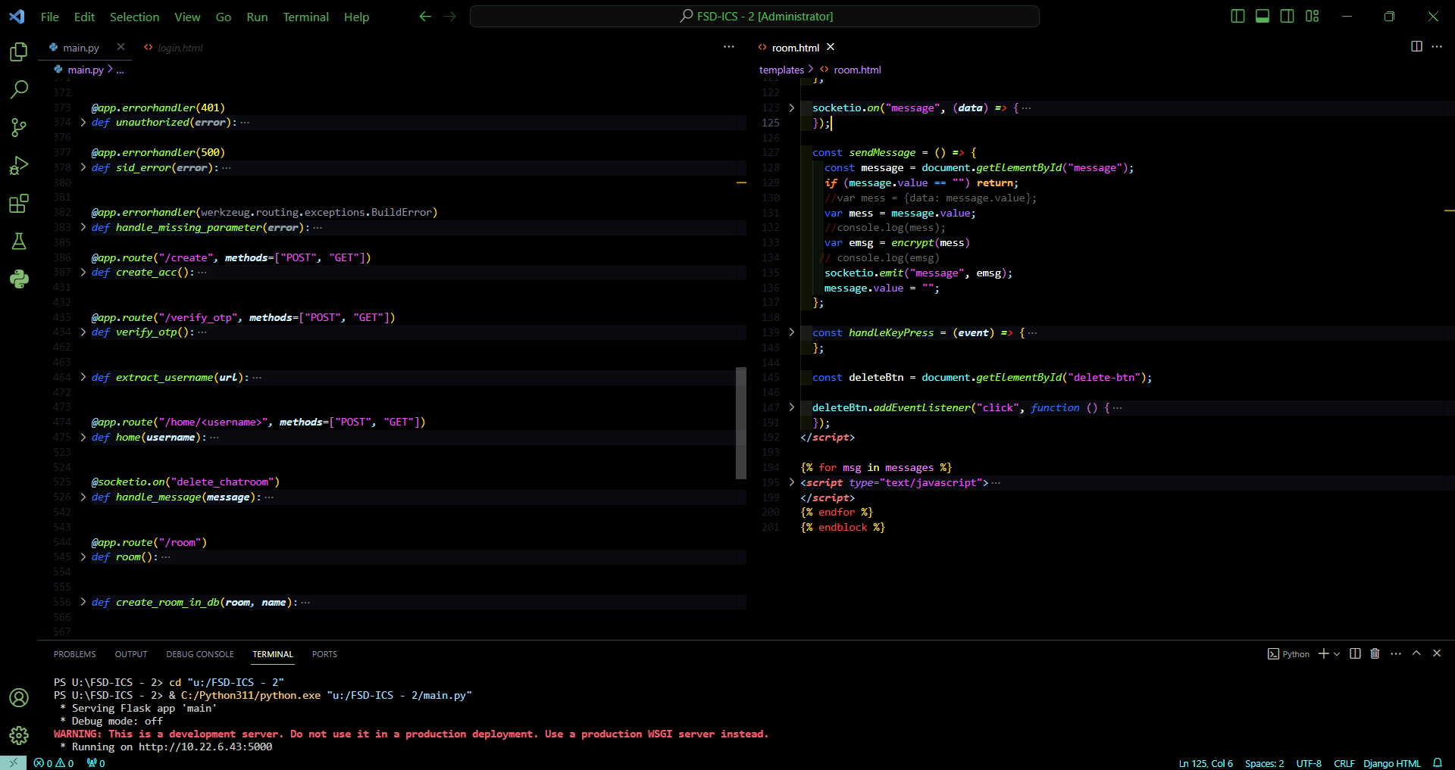

Database: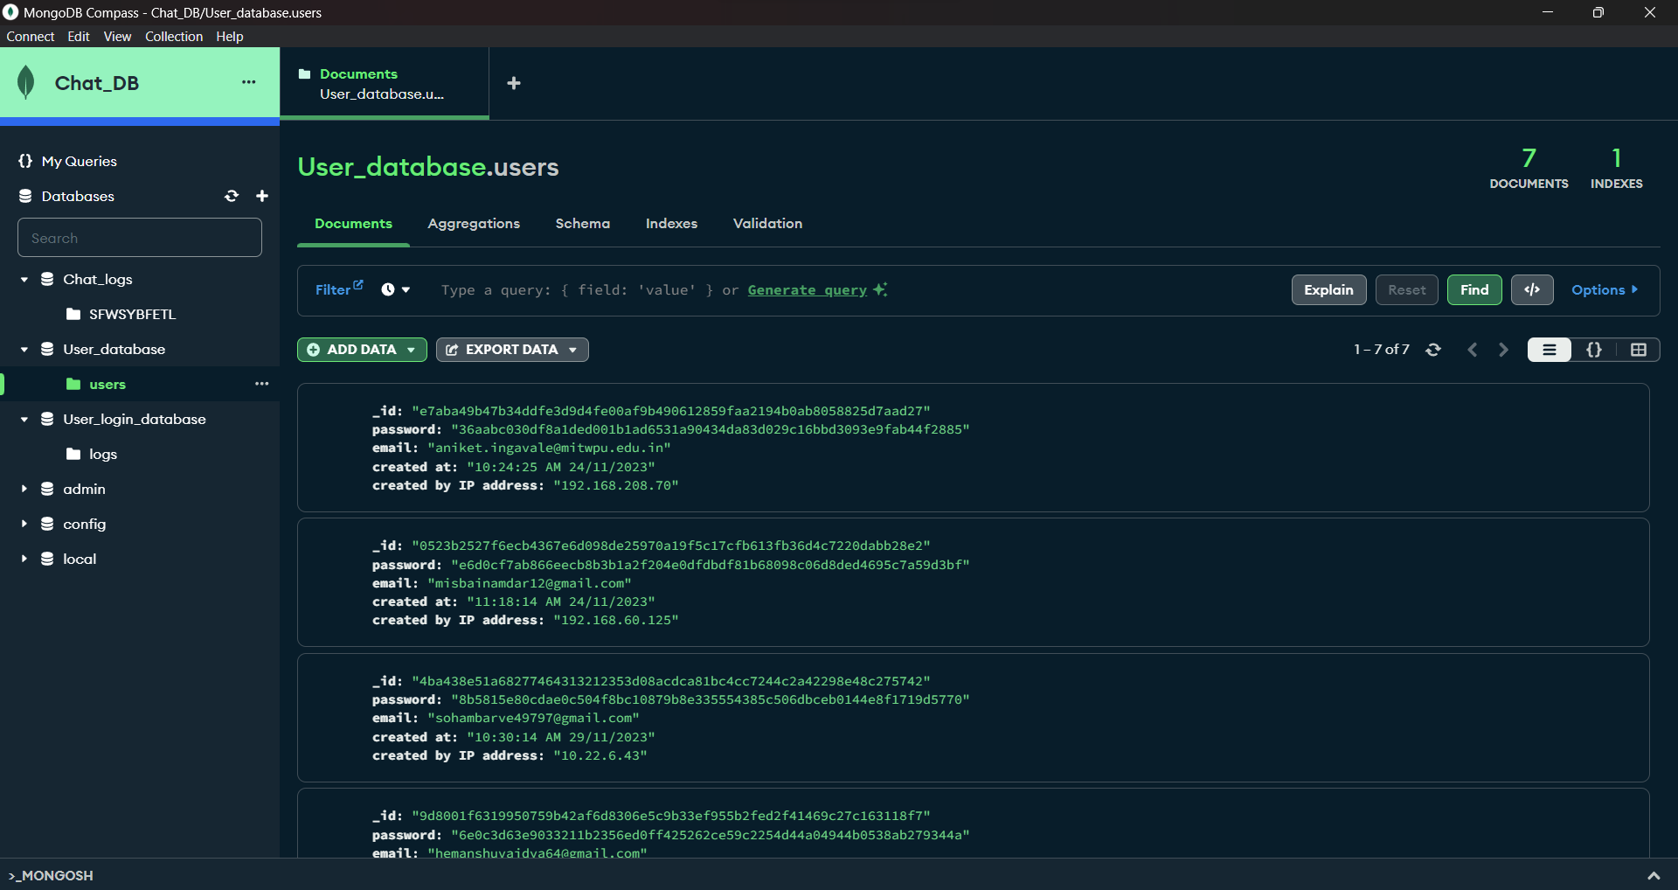

Room (Delete room popup):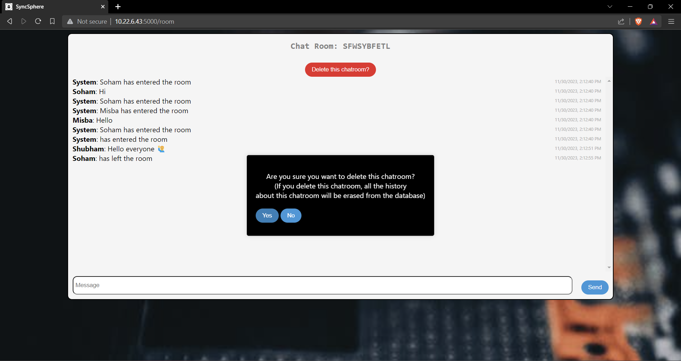

Room: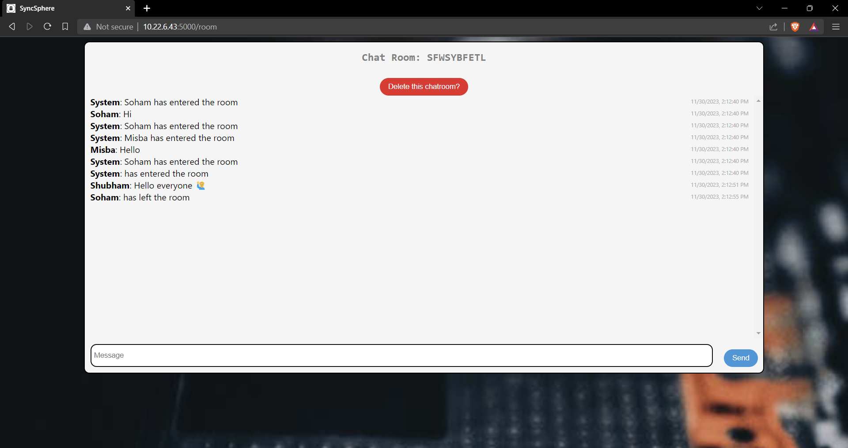

Home page: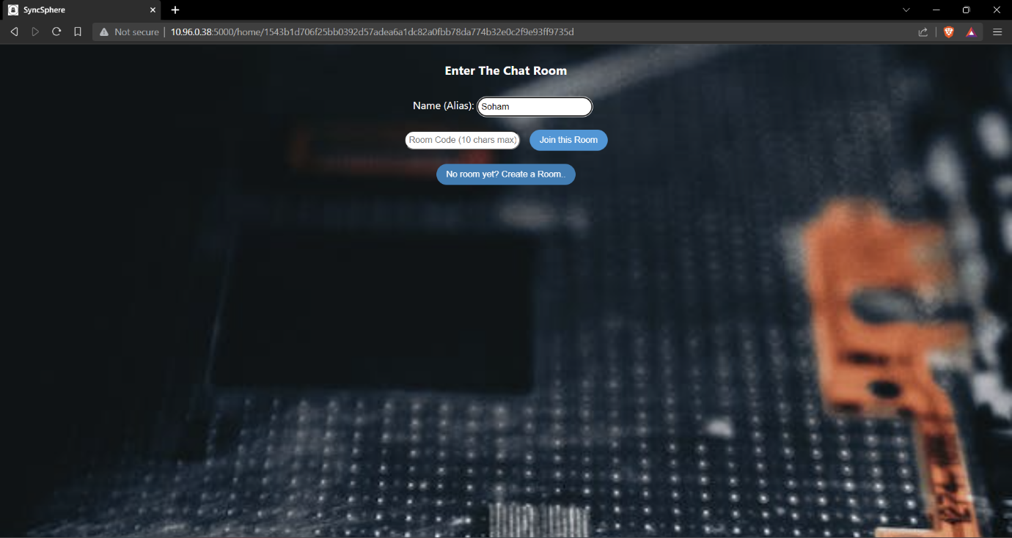

Login Page: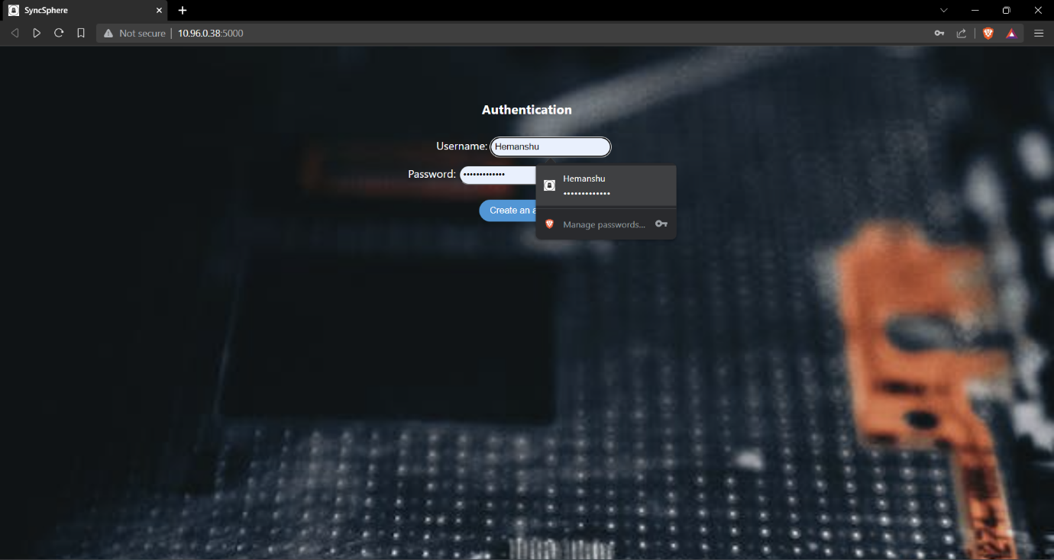

**Conclusion:**

In conclusion, the Full Stack Development project has been an enriching experience, providing practical insights into building scalable and secure web applications. The integration of frontend and backend technologies, along with real-time communication, has broadened our understanding of Full Stack Development concepts. This project not only demonstrates technical proficiency but also emphasizes the importance of user-centric design and security considerations.

**Acknowledgments:**

I extend my gratitude to [Instructor's Name] for guidance and support throughout the project. The knowledge gained from this endeavour will undoubtedly prove valuable as we progress in our academic and professional journey.

This project stands as a testament to the skills acquired in Full Stack Development, showcasing the ability to create robust and feature-rich web applications.

**Thank You**